**IDEATION PHASE**

**PROBLEM STATEMENT**

| Date | 24 September 2022 |
| --- | --- |
| Team ID | PNT2022TMID27832 |
| Team Leader | S.Nikhileshwari (311519104040) |
| Team mates | B.S Jayasree (311519104025)  Sarah Ruth Oommen (311519104052)  G.Shravani (311519104054) |
| Domain Name | Retail and E-commerce |
| Project Name | Inventory Management System for Retailers |
| Maximum marks | 2 marks |

***PROBLEM STATEMENT***

An inventory management system is a critical part of any company. It is what allows us to keep track of all the goods available. The inventory management systems that are currently in use store their data in a fragmented manner in which each department or sector has different pieces of the data. This results in a lack of clarity to make decisions quickly and the need to update all the different pieces to make it consistent. Also due to no commonly accessible storage it leads to overstocking or understocking of goods since the database of purchase details and sale may not be in sync. Along with it exists the problem of the data being device dependent making it inaccessible from anywhere else except that system.Overstocked goods also has to be dealt with efficiently in the case of inaccurate or no analysis and prediction .Thus a system that integrates all the different parts together is essential for the efficient functioning of a company. Hence it necessitates a centralized inventory management system which not only integrates everything seamlessly but also provides multiple access and device independence. Therefore the most viable solution for this would be a cloud based inventory management system that provides all the required features and ensures smooth functioning of the firm.

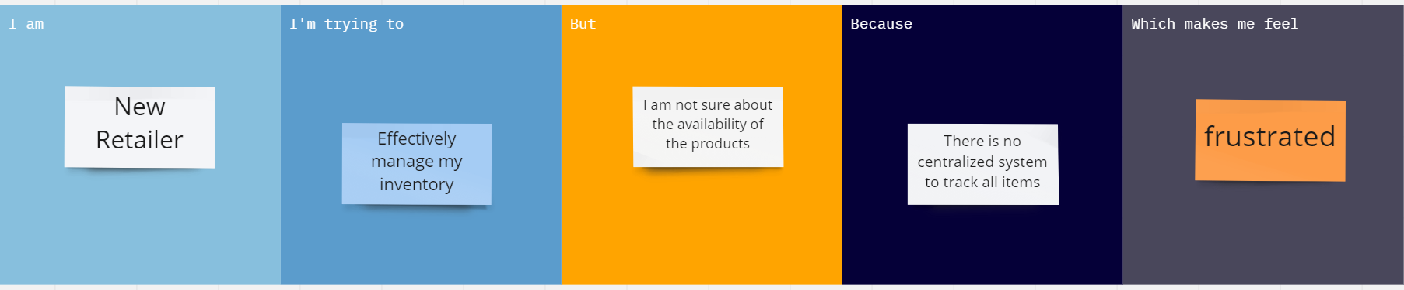

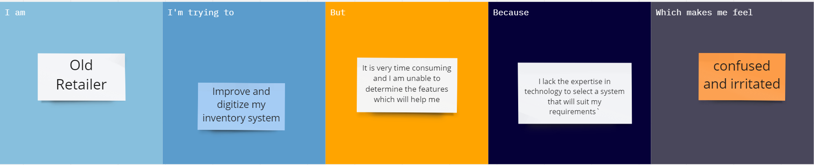

| **Problem Statement (PS)** | **I am** | **I’m trying to** | **But** | **Because** | **Which makes me feel** |
| --- | --- | --- | --- | --- | --- |
| PS-1 | New retailer | Effectively manage my inventory | I am not sure about its availability | There is no centralized system to track all items | frustrated |
| PS-2 | Old retailer | Improve and digitize my inventory system | It is very time consuming and I am unable to determine the features which will help me | I lack the expertise in technology to select a system that will suit my requirements` | confused and irritated |